**Kickstarter Campaign Per Category:**

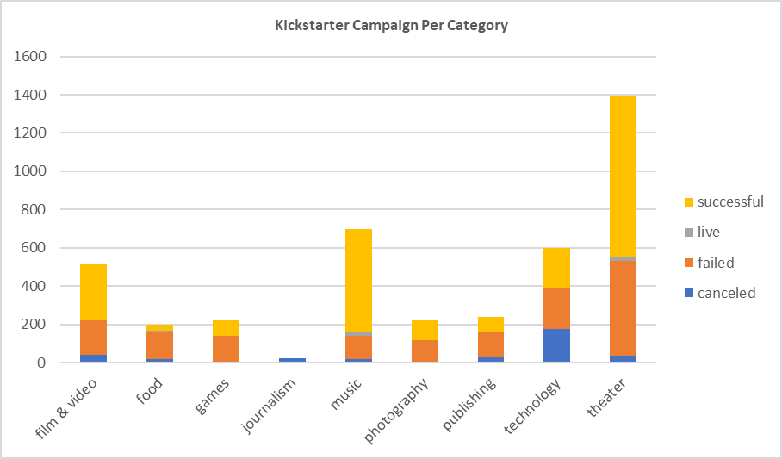

In conclusion, the theater category campaigned the most even though some of the pledges were not met. Also, the campaigns in the theater category was successful when compared with the other categories and the campaigns in the journalism category was the least successful.

A pie chart could be used to interpret the above conclusion.

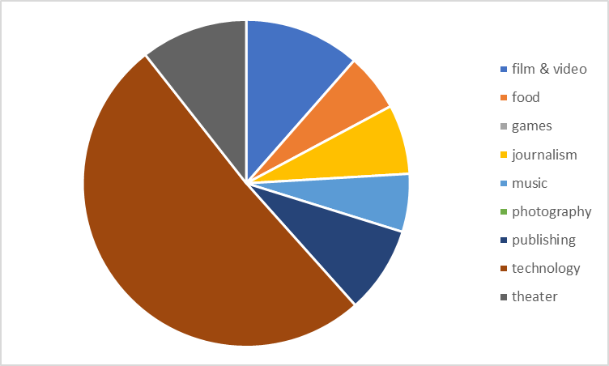

**Kickstarter Campaign Per Sub Category:**

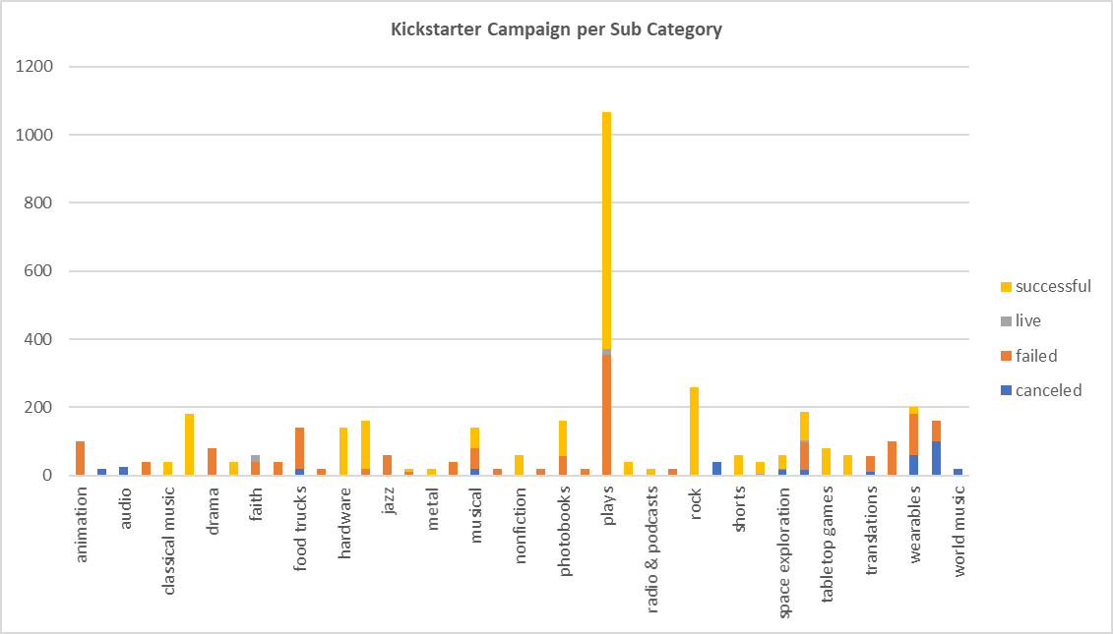

In conclusion, the play sub-category had the most successful outcome and also campaigned to a wider audience.

A pie chart could also use to interpret the above conclusion.

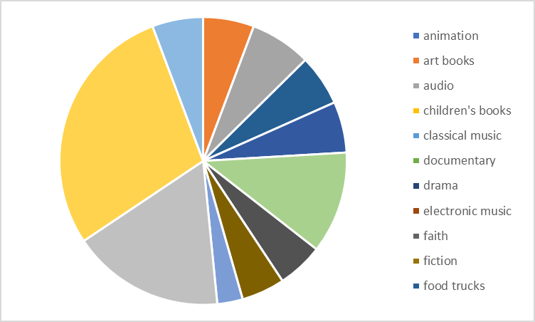

**Kickstarter Monthly Campaign Results:**

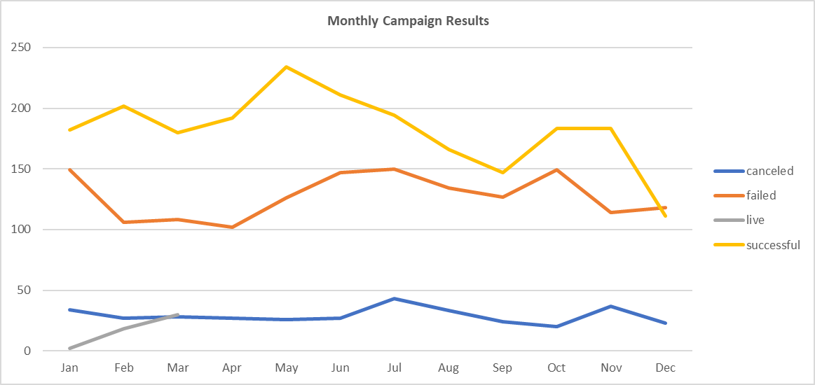

In conclusion, month of February, May and June had over 200 successful campaigns and the month of February, March and April had the less than 110 failed campaigns.

**Limitations to the data set:**

There is not enough data to show how or why pledges were canceled, successful, failed or live.